SQl

DDL-Data definition language

DDL commands-Outer table structute/schema related commands-CREATE,ALTER,DROP,TRUNCATE,COMMENT,RENAME

DML-Data manipulation language-Data content -SELECT,INSERT,UPDATE,DELETE,MERGE,CALL,...

DCL-Data control language-PERMISSION RELATED-GRANT,REVOKE

TCL-transaction control language-COMMIT,ROLLBACK,SAVEPOINT,SET TRANSACTION

2)hOW CAN you filter non duplicate value and unique values retried,

Use keyword DISTINCT keyword

3)Difference between char,varchar datatypes

CHAR -the lenght is fixed.eg id char(5) ,then the values should definitely have 5 fixed char,

Varchar-the length is not fixed,eg,id varchar(5),the string lenght can be any value but max is 5

4)Difference between NOW and CURRENT_DATE(),

Both are built in mysql methods.NOW() shows the current data and time of the server,

Current_date() shows only the date of the erver

5)Join and groupby

6)Different joins with example

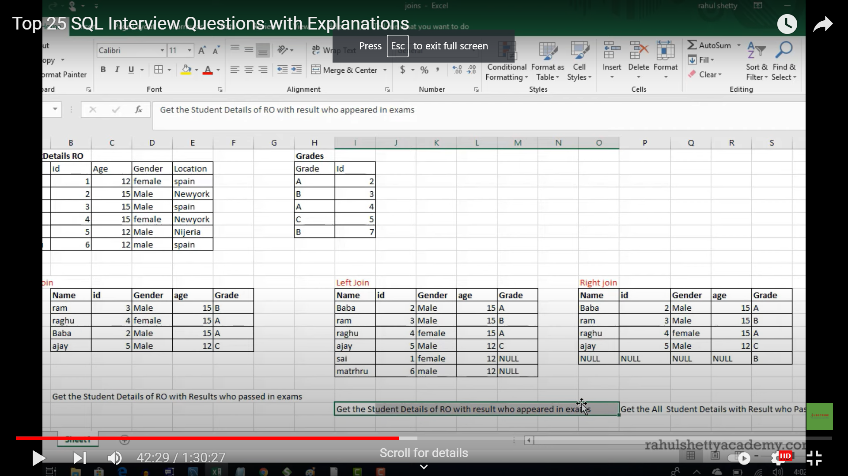

7)Different types of string datatypes used in sql

SET,BLOB,VARCHAR,TEXT,ENUM,CHAR

8)How can you change name of the table

Rename old tablename to new name

9)Difference between primary key,foreign key

The primary key of mysql is used to identify every row in a table in unique manner

Foreign key accepts null,primary key don’t accept null

10)Like operator used with wild card operator % and _(underscore represent single character)

11)BLOB-Binary large object holding huge amount of data

12)Retrieve data in sorted order

13)What is view-virtual table

14)Retrieve only specific number of records-Top(100),limit clause

15)Difference between where and having clause

After group by then we will apply having clause.

Both where and having does filter the records

16)List out aggregate functions

COUNT,SUM,AVG,MAX,MIN

17)Common used sql method

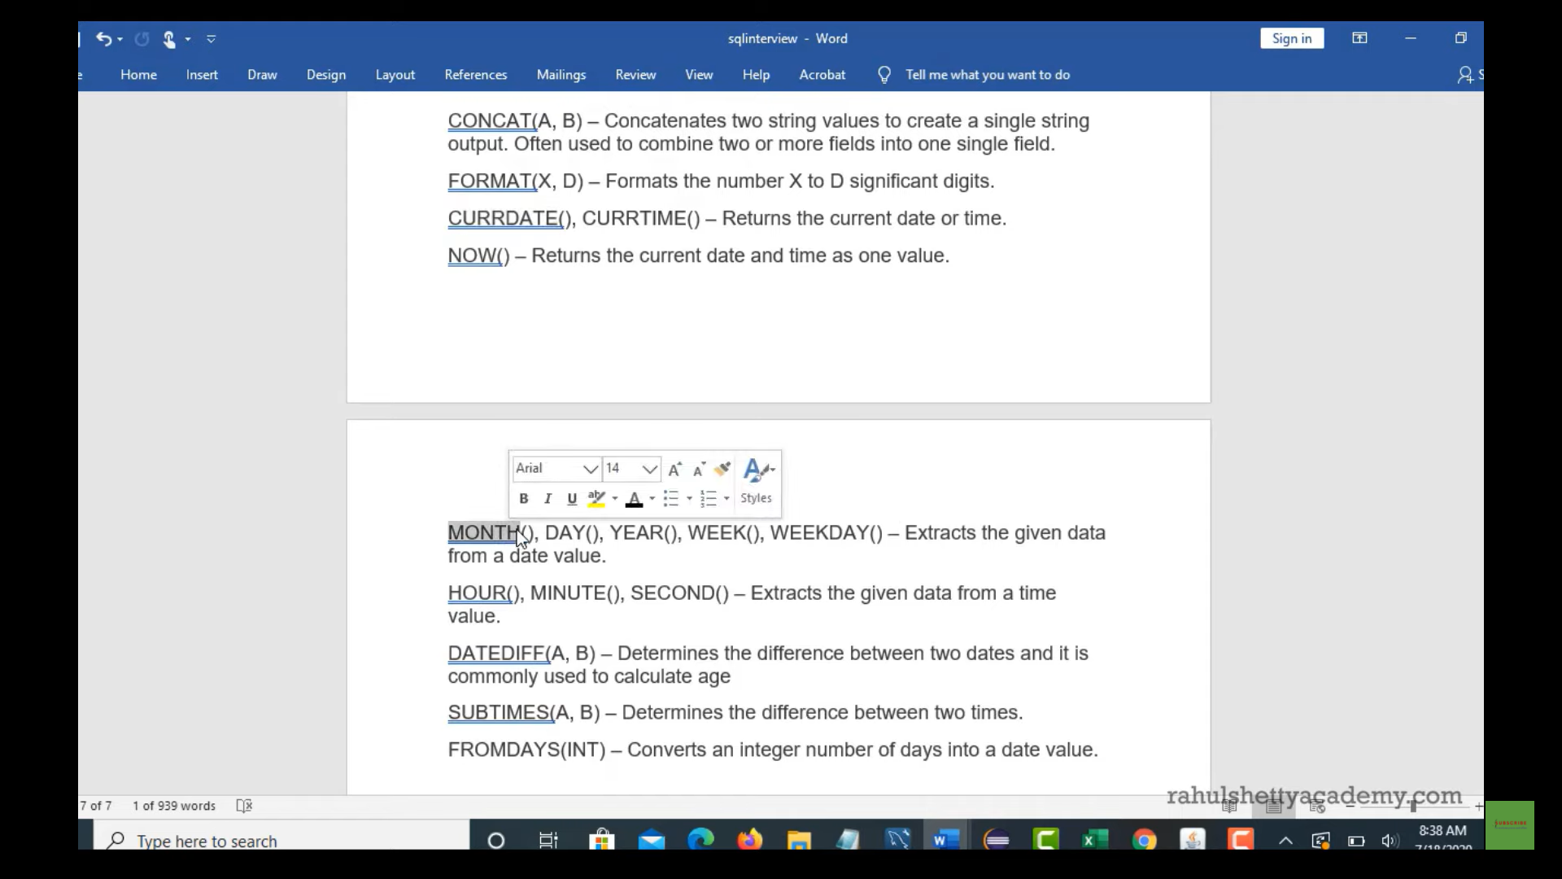

18)What are sql constraints

19)What is default table :dual